Assignment 07 :

Note: To solve below queries, use “sales” database.

- Write a query that lists each order number followed by the name of the customer who made the order.

SELECT o.onum, c.cname
FROM orders o INNER JOIN customers c
ON o.cnum = c.cnum;

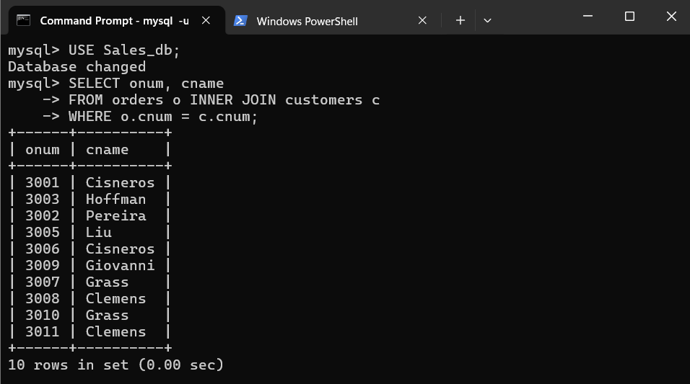
- Write a query that gives the names of both the salesperson and the customer for each order along with the order number.

SELECT o.onum, c.cname, s.sname
FROM orders o
INNER JOIN customers c ON o.cnum = c.cnum
INNER JOIN salespeople s ON o.snum = s.snum;

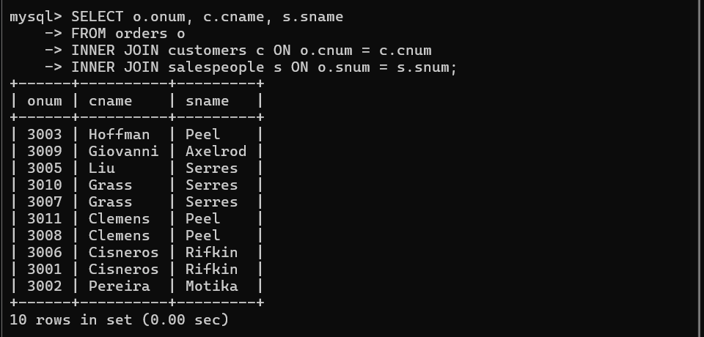

3. Write a query that produces all customers serviced by salespeople with a commission above 12%. Display the customer’s name, the salesperson’s name, and the salesperson’s rate of commission.

SELECT c.cname, s.sname, s.comm
FROM customers c INNER JOIN salespeople s
ON c.snum = s.snum
WHERE s.comm > 0.12;
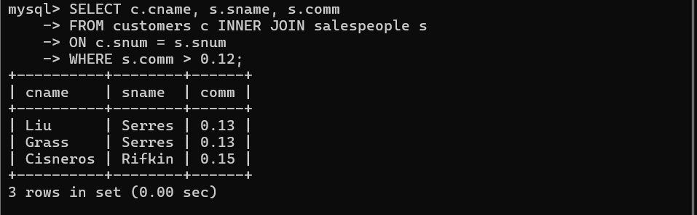

4. Write a query that calculates the commission earned by each salesperson for orders placed by customers with a rating above 100.

SELECT o.onum, c.comm, s.comm * o.amt AS `comm_earned`
FROM orders o INNER JOIN salespeople s
ON o.snum = s.snum
INNER JOIN customers c
ON o.cnum = c.cnum WHERE c.rating > 100;
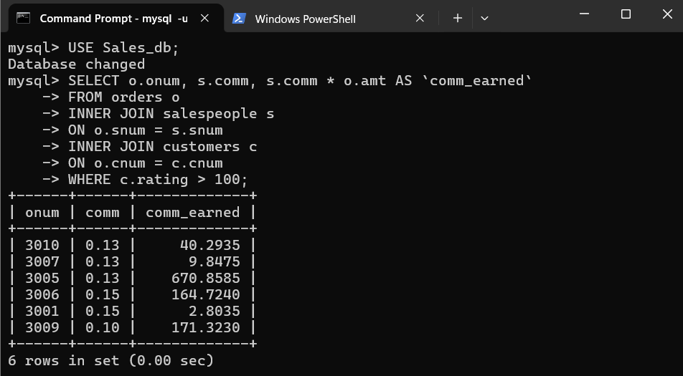

5. Write a query that produces all pairs of salespeople who are living in the same city. Exclude combinations of salespeople with themselves as well as duplicate rows with the order reversed.

SELECT s1.sname salesperson1, s2.sname salesperson2, s1.city
FROM salespeople s1 INNER JOIN salepeople s2
ON s1.city = s2.city WHERE s1.snum < s2.snum;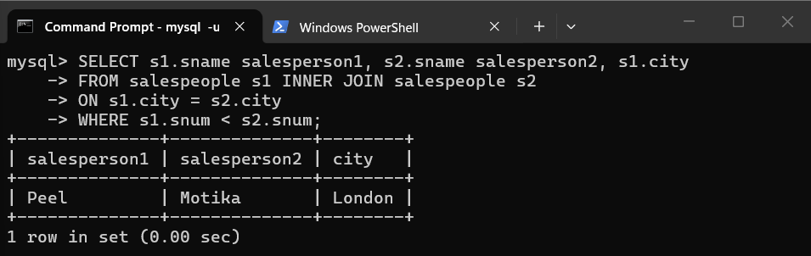
Note: To solve below queries, use “spj” database

1. Display the Supplier name and the Quantity sold.
SELECT s.sname, SUM(sp.qty)
FROM s INNER JOIN sp ON s.`S#` = sp.`S#`
GROUP BY s.sname;

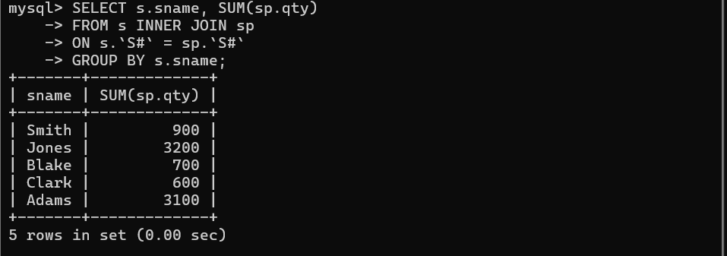

- Display the Part name and Quantity sold.

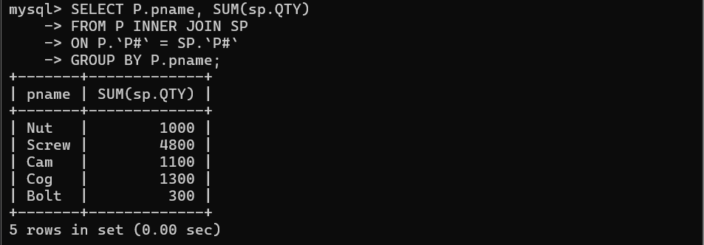
- Display the Job name and Quantity sold.

SELECT J.Jname, SUM(SP.QTY)
FROM J INNER JOIN SP
ON J.`J#` = SP.`J#`
GROUP BY J.Jname;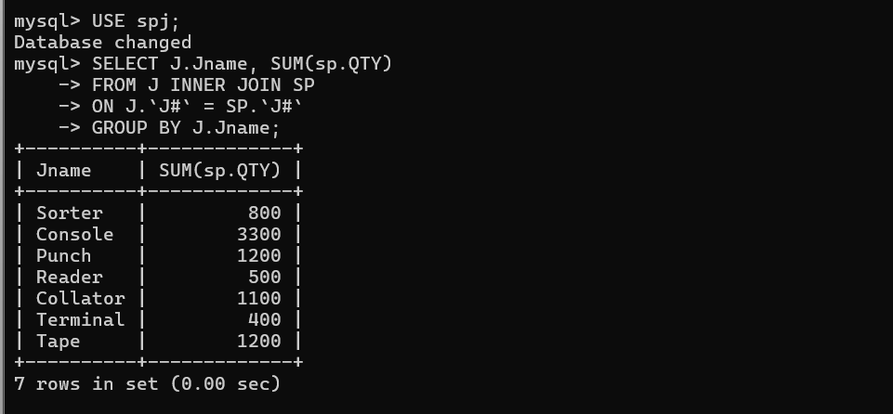

- Display the Supplier name, Part name, Job name and Quantity sold.

SELECT S.sname, P.pname, J.jname, SP.QTY
FROM SP INNER JOIN S ON SP.`S#` = S.`S#`
INNER JOIN P ON SP.`P#` = P.`P#`
INNER JOIN J ON SP.`J#` = J.`J#`
ORDER BY S.sname DESc;
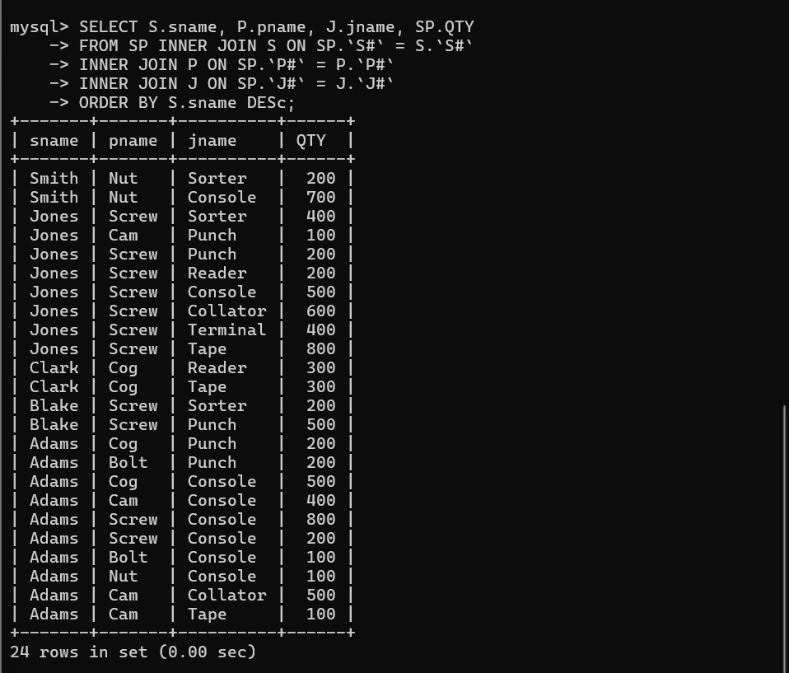

- Display the Supplier name, Supplying Parts to a Job in the same City.

SELECT DISTINCT S.sname
FROM S INNER JOIN SP
ON S.`S#` = SP.`S#`
INNER JOIN J
ON SP.`J#` = J.`J#`
WHERE S.city = J.city;

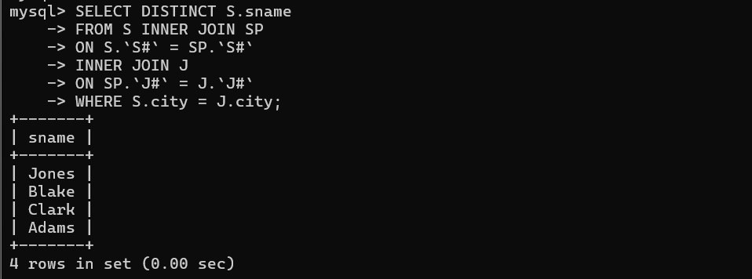

- Display the Part name that is ‘Red’ in color, and the Total Quantity sold for that part.

SELECT P.pname, SUM(SP.QTY)
FROM P INNER JOIN SP
ON P.`P#` = SP.`P#`
WHERE P.color = 'Red'
GROUP BY P.pname;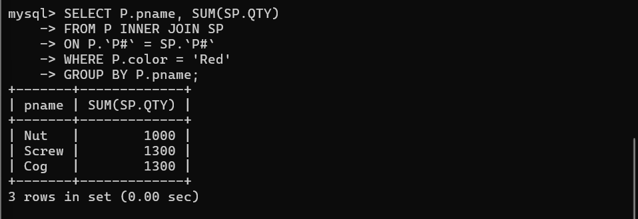
7. Display all the Quantity sold by Suppliers with the Status = 20.
SELECT S.sname, SUM(SP.QTY)
FROM S INNER JOIN SP
ON S.`S#` = SP.`S#`
WHERE S.status = 20
GROUP BY S.sname;
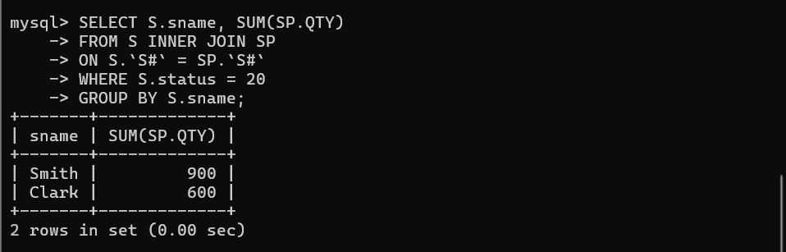

- Display all the Parts and their Total Quantity for the parts with the Weight > 14.

SELECT P.pname, P.weight, SUM(SP.QTY)
FROM P INNER JOIN SP
ON P.`P#` = SP.`P#`
WHERE P.weight > 14
GROUP BY P.pname, P.weight;

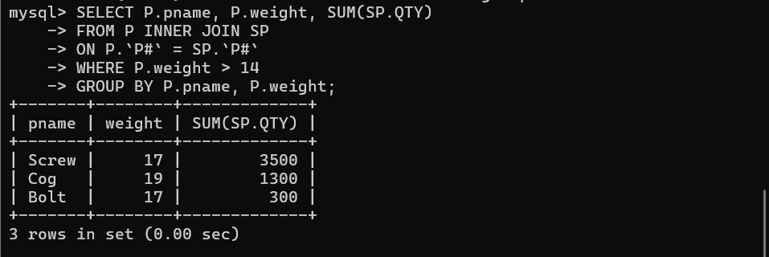

- Display all the Job names and City, which has bought more than 500 Parts.

SELECT J.jname, J.city, SUM(SP.QTY) AS Total_QTY
FROM J INNER JOIN SP
ON J.`J#` = SP.`J#`
GROUP BY J.jname, J.city
HAVING total_QTY > 500;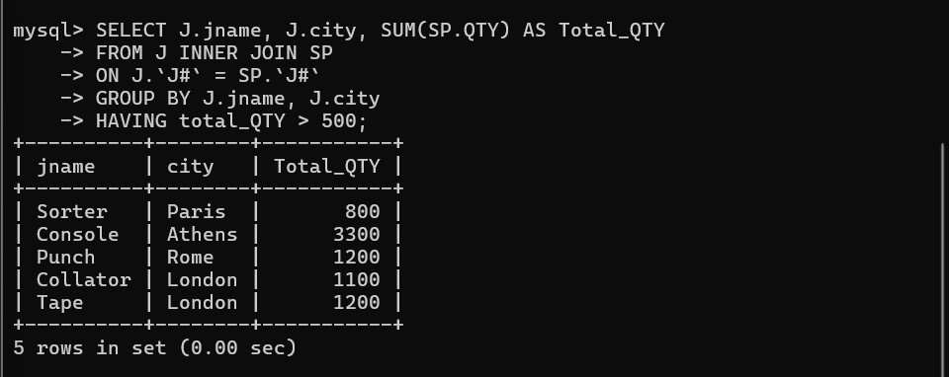
- Display all the Part names and Quantity sold that have a Weight less than 15.

SELECT P.pname, SUM(SP.QTY) AS QTY_Sold
FROM P INNER JOIN SP
ON P.`P#` = SP.`P#`
WHERE P.weight < 15
GROUP BY P.pname;
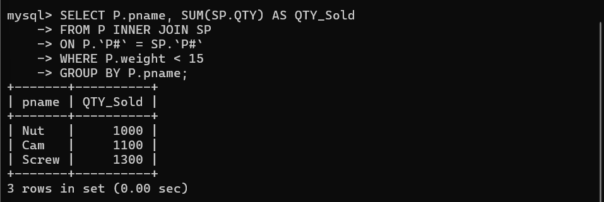

- Display all the Suppliers with the same Status as the supplier, ‘CLARK’.

SELECT s1.sname, s1.status
FROM S s1 INNER JOIN S s2
ON s1.status = s2.status
WHERE s2.sname = ‘CLARK’ AND s1.name != ‘CLARK’;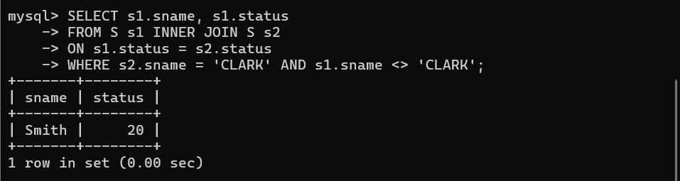

- Display all the Parts which have more Weight than any “Red” parts.

SELECT DISTINCT p1.pname, p1.weight, p1.color
FROM P p1 INNER JOIN P p2
ON p1.weight > p2.weight
WHERE p2.color = ‘Red’;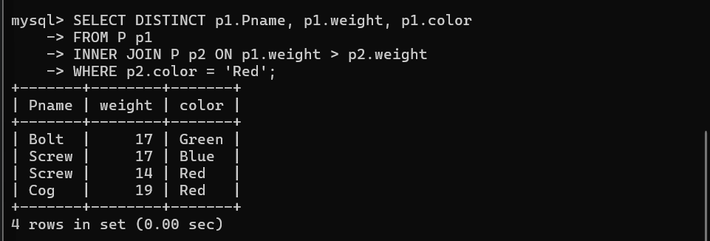

13. Display all the Jobs going on in the same city as the job ‘TAPE’.

SELECT j1.Jname, j1.city
FROM J j1 INNER JOIN J j2
ON j1.city = j2.city
WHERE j2.Jname = 'TAPE' AND j1.Jname != 'TAPE';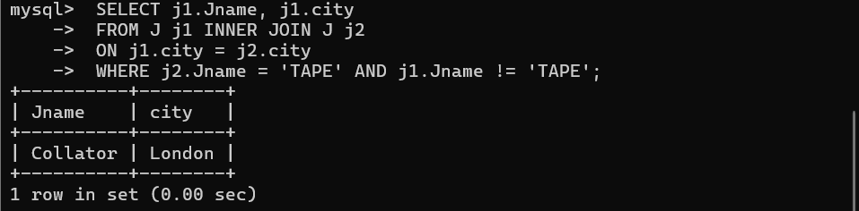14. Display all the Parts with Weight less than any of the “Green” parts.

SELECT p1.pname, p1.weight
FROM P p1 INNER JOIN P p2
ON p1.weight < p2.weight
WHERE p2.color = 'Green';
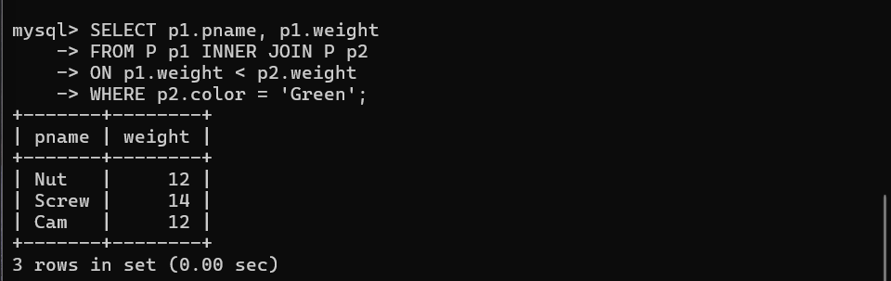

15. Display the name of the Supplier who has sold the maximum Quantity (in one sale).

SELECT S.sname, MAX(SP.QTY)
FROM S INNER JOIN SP ON S.`S#` = SP.`S#`
GROUP BY S.sname
ORDER BY MAX(SP.QTY) DESC
LIMIT 1;
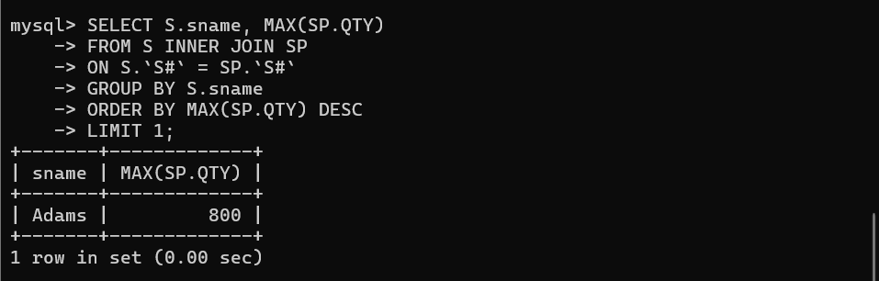

16. Display the name of the Supplier who has sold the maximum overall Quantity (sum of Sales).

SELECT S.sname, SUM(SP.QTY)
FROM S INNER JOIN SP
ON S.`S#` = SP.`S#`
GROUP BY S.sname
ORDER BY SUM(SP.QTY) DESC
LIMIT 1;


